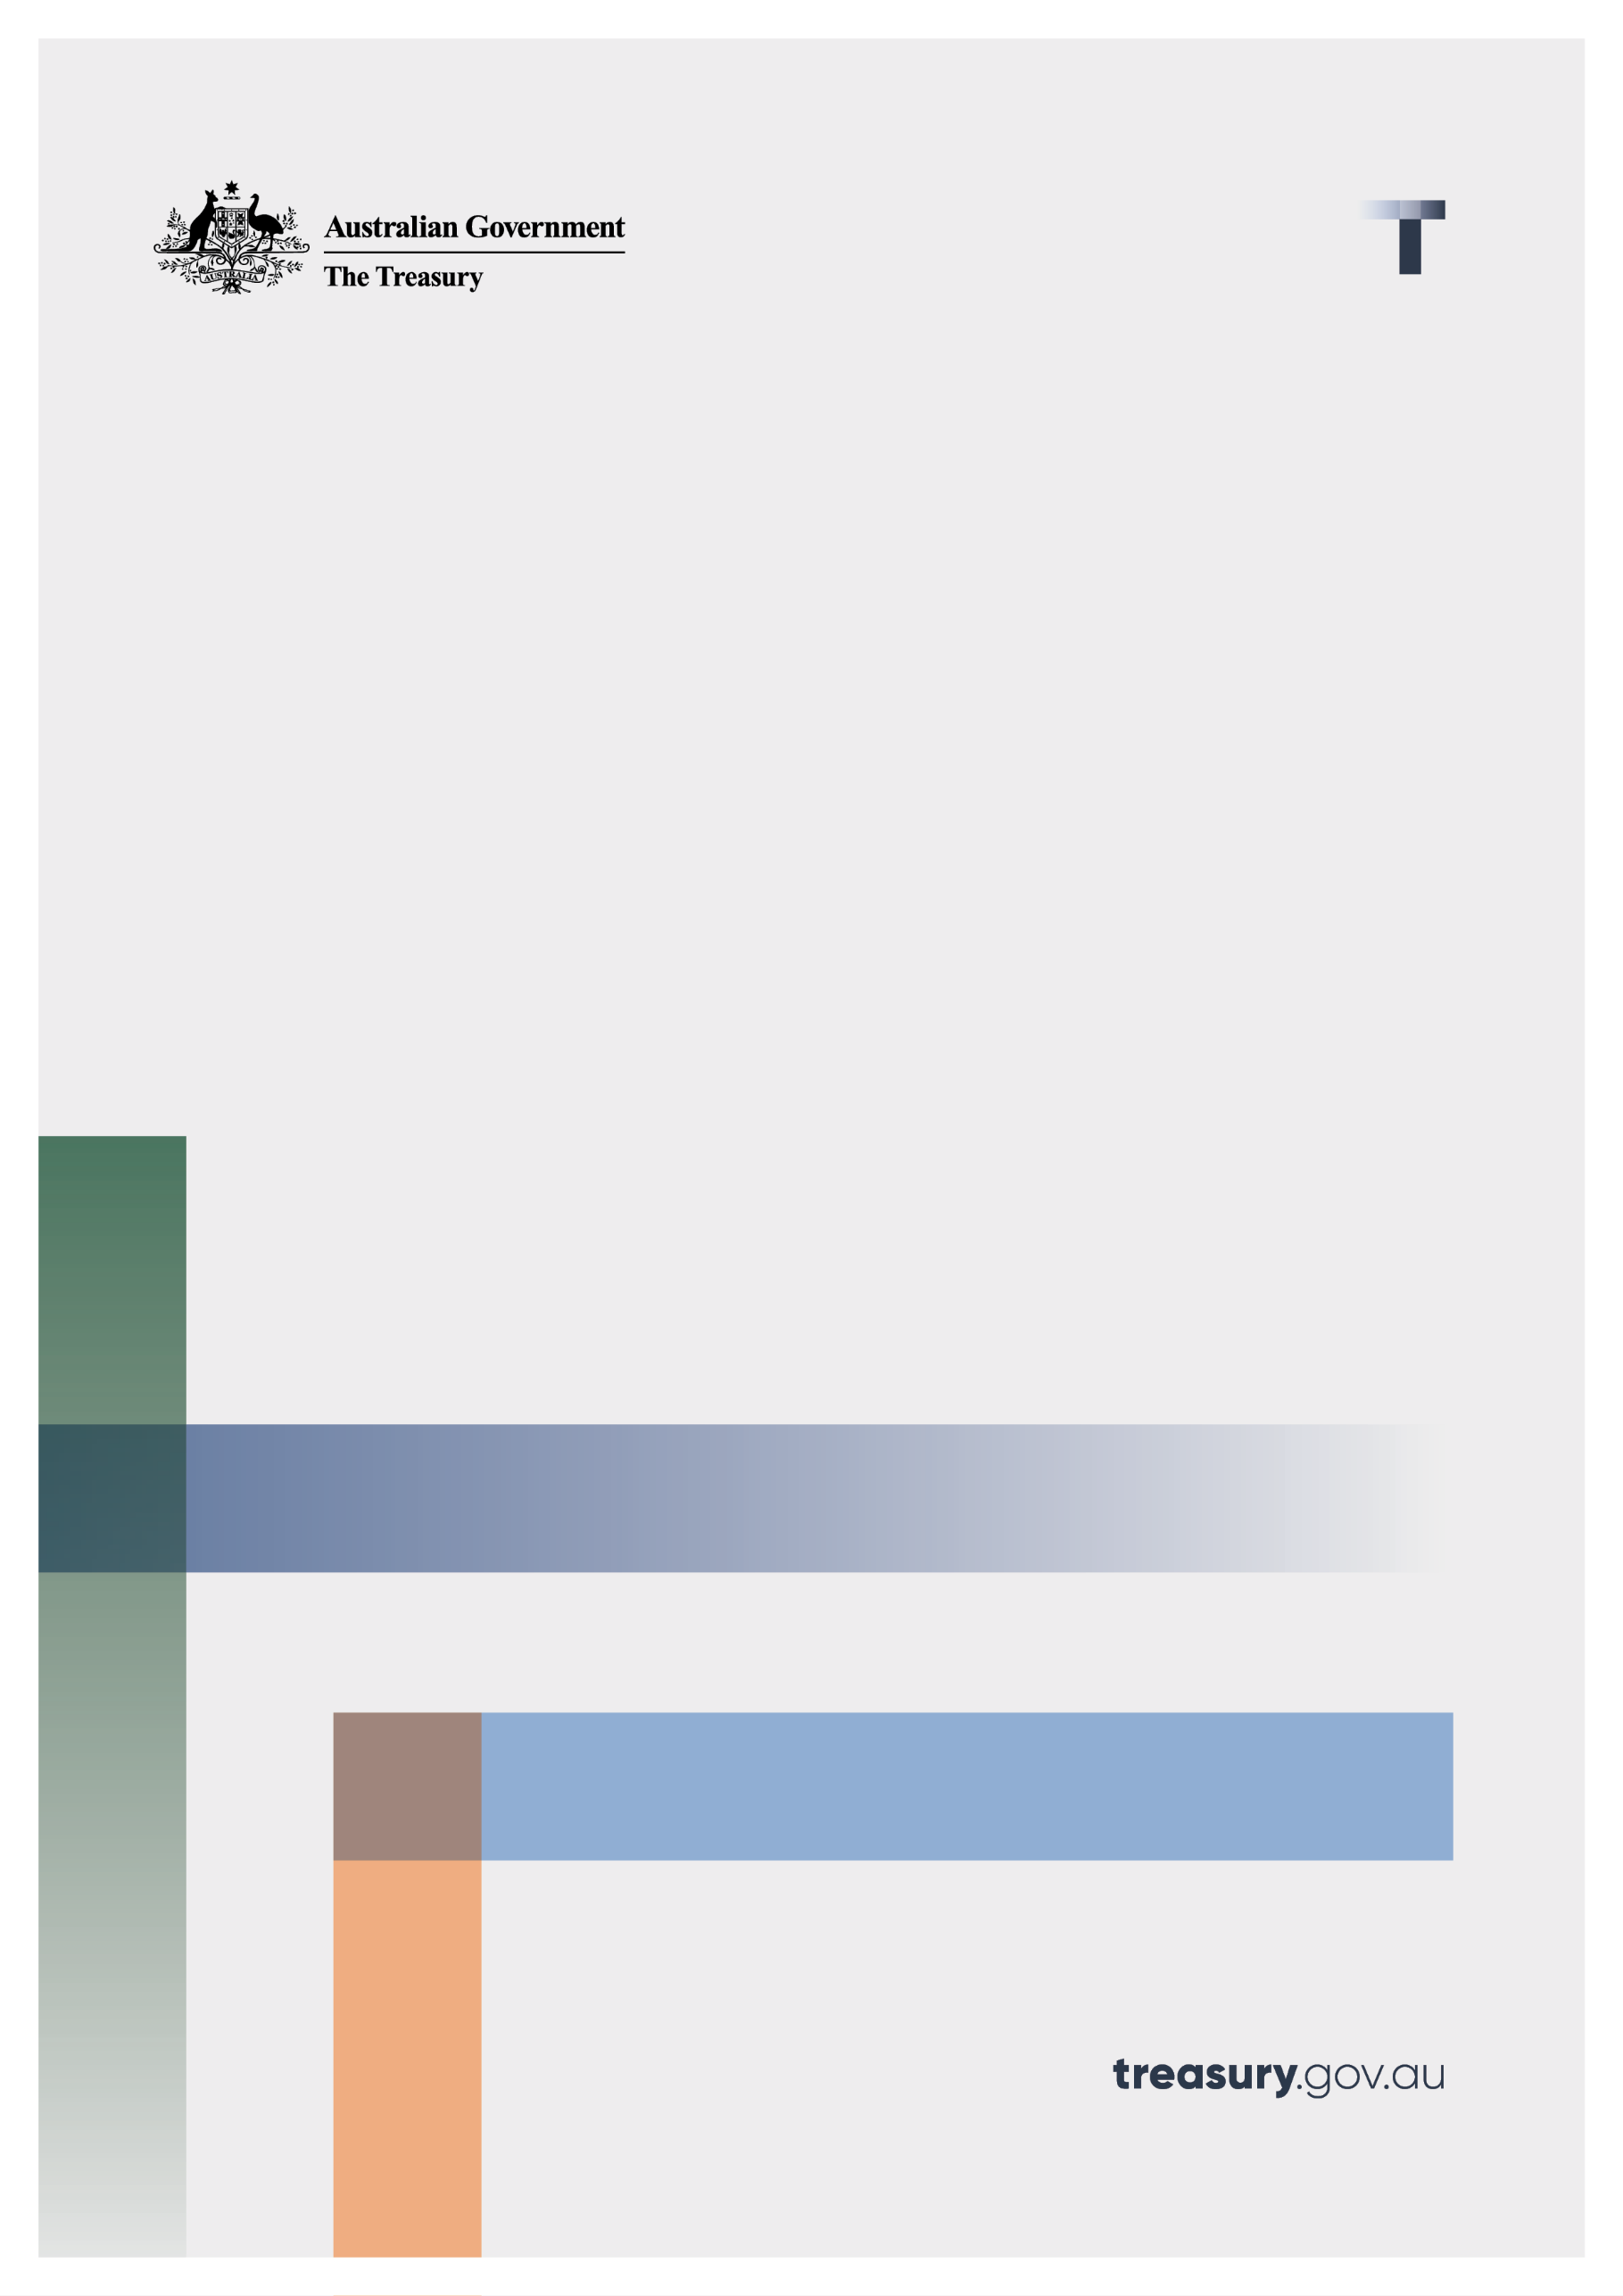

Vapour Recovery Units - Single Rate

Consultation paper

September 2023

© Commonwealth of Australia 2023

This publication is available for your use under a [Creative Commons Attribution 3.0 Australia](http://creativecommons.org/licenses/by/3.0/au/deed.en) licence, with the exception of the Commonwealth Coat of Arms, the Treasury logo, photographs, images, signatures and where otherwise stated. The full licence terms are available from <http://creativecommons.org/licenses/by/3.0/au/legalcode>.

Creative Commons attribution licence 3.0 icon. 

Use of Treasury material under a [Creative Commons Attribution 3.0 Australia](http://creativecommons.org/licenses/by/3.0/au/deed.en) licence requires you to attribute the work (but not in any way that suggests that the Treasury endorses you or your use of the work).

**Treasury material used ‘as supplied’**

Provided you have not modified or transformed Treasury material in any way including, for example, by changing the Treasury text; calculating percentage changes; graphing or charting data; or deriving new statistics from published Treasury statistics — then Treasury prefers the following attribution:

*Source: The Australian Government the Treasury*

**Derivative** **material**

If you have modified or transformed Treasury material, or derived new material from those of the Treasury in any way, then Treasury prefers the following attribution:

*Based on The Australian Government the Treasury data*

**Use of the Coat of Arms**

The terms under which the Coat of Arms can be used are set out on the Department of the Prime Minister and Cabinet website (see [www.pmc.gov.au/government/commonwealth-coat-arms](http://www.pmc.gov.au/government/commonwealth-coat-arms)).

**Other uses**

Enquiries regarding this licence and any other use of this document are welcome at:

Manager  
Media Unit  
The Treasury  
Langton Crescent   
Parkes ACT 2600  
Email: [media@treasury.gov.au](mailto:media@treasury.gov.au)

# Contents

Contents ii

Consultation Process 3

Request for feedback and comments 3

Single Rate for Vapour Recovery Units 4

Introduction 4

Purpose 4

Discussion 4

Appendix 7

# Consultation Process

## Request for feedback and comments

You can submit responses to this consultation up until 03 October 2023.

While submissions may be lodged electronically or by post, electronic lodgement is preferred. For accessibility reasons, please submit responses sent via email in a Word or RTF format. An additional PDF version may also be submitted.

All information (including name and address details) contained in submissions will be made available to the public on the Treasury website unless you indicate that you would like all or part of your submission to remain in confidence. Automatically generated confidentiality statements in emails do not suffice for this purpose. Respondents who would like part of their submission to remain in confidence should provide this information marked as such in a separate attachment.

Legal requirements, such as those imposed by the *Freedom of Information Act 1982*, may affect the confidentiality of your submission.

View our [submission guidelines](https://treasury.gov.au/submission-guidelines) for further information.

Closing date for submissions: 03 October 2023

|  |  |
| --- | --- |
| Email | Indirecttax@treasury.gov.au |
| Mail | Tax Framework, Indirect, Industry and State Taxes Branch  Personal and Indirect Tax and Charities Division  The Treasury  Langton Crescent  PARKES ACT 2600 |
| Enquiries | Enquiries can be initially directed to the Indirect Tax Unit |
| Phone | 02 6263 2111 |

The principles outlined in this paper have not received Government approval and are not yet law. As a consequence, this paper is merely a guide as to how the principles might operate.

# Single Rate for Vapour Recovery Units

## Introduction

The Government is consulting on a single rate for businesses to calculate and claim excise refunds on returned petroleum recovered through a Vapour Recovery Unit (VRU). This change was announced by the previous Government in the March 2022-23 Budget as part of the *Streamlining excise administration for fuel and alcohol deregulation package*, with the start date delayed by the Government from 1 July 2023 to 1 July 2024 in the May 2023-24 Budget.

## Purpose

The Government is consulting on a single average benchmark recovery rate for use by businesses to calculate and claim excise refunds on returned duty paid petroleum recovered through a Vapour Recovery Unit (VRU).

A refund of excise duty can be claimed where vapour that is collected from a tank at a service station is returned to the licensed fuel terminal or refinery and converted back into liquid fuel using a VRU[1]. Currently, each established VRU is required to be tested by certified, independent testers every six months to establish the rate at which vapours are converted into liquid at a particular VRU. The results from these tests are used to calculate excise refunds on returned vapours. This process is a burden on businesses.

The establishment of a single rate is expected to result in a regulatory saving for businesses through the reduction in frequency of testing of VRUs and the resources businesses dedicate to claiming the refund relative to the amount of the refunds received. The establishment of a single rate will remove the need for regular testing of VRU units for the purpose of claiming an excise refund on returned petroleum however, there may be other non-tax reasons why some testing may still be required.

This consultation paper covers the proposed average recovery rate and a proposed simplified formula in which it is employed to calculate the volume of returned duty paid petroleum recovered through a VRU. It will inform the drafting of legislation and explanatory materials to implement the measure.

# Discussion Questions

## Proposed Average Recovery Rate

The Government is seeking comments on introducing a new average recovery rate for VRUs (Rav)[2] which is determined by averaging the VRU efficiency (E) values and fraction of hydrocarbon vapour in gas entering the VRU (Yin) of bi-annual test results over the 5-year period from 2017 to 2022 (10 test results per VRU), that was provided by industry for 17 VRU sites across Australia.[3] Data points for Yin and low E of greater than 1 standard deviation were treated as outliers and removed prior to calculating the average recovery rate.

Using this approach, the proposed Rav for duty-paid liquid fuel recovered from vapours within an excise licensed premise is **0.0006442 (0.06442 per cent)[4].**

It is anticipated that the use of this proposed Rav will result in a statistically distributed variance of excise refund claims, compared to the current use of individual recovery rates for each VRU. That is, on a VRU site basis, compared to the current arrangements, some refund claims will be higher, some lower and others roughly the same.

### Discussion question 1

Does the methodology for determining the proposed single Rav present any issues?

## Proposed formula for calculating volume of liquid recovered using the new average recovery rate

The formulaic approach for calculating excise refunds of *liquid* petroleum, which have been returned to an excise licensed premise, from recovered petroleum vapours using a VRU was agreed upon by both the ATO and the petroleum industry as an equitable method. It is based on the two-year trial of the VRU testing process as originally described in a consultation paper prepared by Professor David Trimm - *Vapour Recovery in the Petroleum Industry,* (July 1998). It has been in place as an administrative policy within the ATO since April 2002.

The proposed new formula in which Rav is employed (Equation 1) is a variation of Professor Trimm’s formula as described in the original paper (which can be found in attachment A) that is currently used by industry participants:

**Equation 1**

**Volume of liquid = Volume of gas entering the unit x Rav**

Where:

**Volume of liquid** = volume of duty-paid liquid petroleum recovered from vapours on which the excise refund can be claimed

**Volume of gas entering the unit** = volume of motor fuel throughput (gasoline, gasoline blends, diesel and diesel blends) loaded into tankers connected to a VRU and entered into home consumption.

**Rav** = 0.0006442

### Discussion question 2

Does the new simplified formula (Equation 1) employing Rav for use in calculating volumes of liquid petroleum on which a refund can be claimed meet the objective of the March 2022-23 Budget measure?

## Proposed refund cut-off threshold when using the new average recovery rate

Professor Trimm’s formula assumed that the fraction of diesel vapour in the gas entering the VRU is zero as the higher boiling temperature of diesel means it produces significantly less hydrocarbon vapours in the space above the liquid compared to gasoline.

Currently, in order for recoveries calculated for a particular VRU to be acceptable for refund purposes, the test results have to be reflective of the diesel to gasoline loading patterns during the relevant duty period. Where the ratio of diesel to gasoline is greater than ±15 % of that during the test period, adjusted values are calculated for the fraction of hydrocarbon vapour in gas entering the VRU (Yin), the fraction of hydrocarbon vapour in gas leaving the VRU (Yout) and consequently the efficiency (E) values and the volume of liquid recovered.

As the new **Rav**  is based on the average Yin and E values for 17 VRU sites across Australia, there is no ‘true’ diesel to gasoline loading pattern for the test period with which to measure against the loading patterns during the relevant duty period.

In line with the deregulation proposal to reduce the complexity of claiming VRU refunds, it is proposed that excise duty refunds will only be applicable when the diesel to gasoline loading pattern ratio during the relevant duty period is not greater than 75:25 and no adjustments will be required.

### Discussion question 3

Does the use of a refund cut-off threshold, when the diesel to gasoline loading pattern ratio is greater than 75:25 during the relevant duty period (with no requirement for adjustment) address the diesel to gasoline throughput equitably, and if not can you suggest a more equitable method?

# Appendix A

## Derivation of Rav

The formulaic approach agreed upon by both the ATO and the petroleum industry as described on pages 18-21 of the consultation paper prepared by Professor David Trimm - *Vapour Recovery in the Petroleum Industry,* (July 1998) is:

**Equation 2**

|  |  |
| --- | --- |
| Volume of liquid = | Volume of gas entering the unit x Yin x E x F |
| **23.6455** |

Where:

**Volume of liquid** = volume of excisable liquid fuel on which the refund can be claimed

**Volume of gas entering the unit** = volume of fuel throughput entered into home consumption

**Yin**= Fraction of hydrocarbon vapour in gas entering the VRU

**E** = VRU efficiency

**F** = Vapour to liquid conversion factor (0.10925)

The variables Yin and E need to be established by independent accredited testing every six months and be available for consideration by the ATO within six weeks of the test being successfully completed. Equation 1 is a variation of Prof. Trimm’s original formula in Equation 2:

**Equation 1**

**Volume of liquid = Volume of gas entering the unit x Rav**

Where:

**Equation 3**

**Rav** **= Yinav x Eav x F / 23.6455**

**Rav**: Average recovery rate of all VRU’s tested over 5 year period 2017-2022

**Yinav**: Average of fraction of hydrocarbon vapour in gas entering all VRU’s tested over the 5 year period

**Eav**: Average efficiency of all VRU’s tested over the 5 year period

**F**: Vapour to liquid conversion factor (0.10925)

VRU testing data obtained over the 5 years provided an average Yin (Yinav) of 0.1406 (14.06%) and average Efficiency (Eav) of 0.9917 (99.17%).

Transposing Yinav, Eav and F into Equation 3 results in:

**Rav** **= 0.1406 x 0.9917 x 0.10925 / 23.6455**

**Rav =0.0006442 (rounded at 7th decimal place)**

Transposing the calculated average recovery rate Rav into equation 1 provides for a conversion factor of 0.0006442 (0.06442%).

# Appendix B

## Average efficiency (E) and Average of fraction of hydrocarbon vapour in gas entering VRU (Yin) used to calculate Rav

|  |  |  |  |  |  |  |  |  |  |
| --- | --- | --- | --- | --- | --- | --- | --- | --- | --- |
| **Vapour Recovery Unit** | **Average of Yin (%)** | | **Std Dev of Average Yin (%)2** | | **Average of Unit Efficiency (E%)** | | | **StdDev of Unit Efficiency (E%) 2** | |
| 1 | 13.45 | | 6.29 | | 99.42 | | | 0.43 | |
| 2 | 14.21 | | 5.65 | | 98.94 | | | 0.90 | |
| 3 | 14.06 | | 5.32 | | 99.57 | | | 0.29 | |
| 4 | 18.79 | | 5.47 | | 99.29 | | | 0.47 | |
| 5 | 11.84 | | 4.05 | | 99.31 | | | 0.49 | |
| 6 | 7.78 | | 2.94 | | 99.27 | | | 0.43 | |
| 7 | 11.73 | | 3.53 | | 99.63 | | | 0.58 | |
| 8 | 14.44 | | 5.78 | | 99.45 | | | 0.36 | |
| 9 | 13.59 | | 3.52 | | 98.36 | | | 1.83 | |
| 10 | 7.50 | | 3.59 | | 96.48 | | | 2.15 | |
| 11 | 21.52 | | 4.38 | | 99.33 | | | 0.85 | |
| 12 | 12.32 | | 6.21 | | 99.26 | | | 0.75 | |
| 13 | 29.79 | | 4.19 | | 99.89 | | | 0.10 | |
| 14 | 10.73 | | 4.20 | | 99.59 | | | 0.23 | |
| 15 | 9.37 | | 4.94 | | 99.30 | | | 0.27 | |
| 16 | 10.79 | | 4.44 | | 99.76 | | | 0.17 | |
| 17 | 17.19 | | 5.19 | | 99.01 | | | 2.25 | |
|  |  |  | |  | | |  | | |
|  | **Total Average** |  | | | |  | | |
| Av Yin | 14.06 |  | | | |  | | |
| Av Unit Eff | 99.17 |  | | | |  | | |

*Averages are taken from raw data provided by industry to the ATO.

1. Refunds of duty for excisable goods returned to a licensed premise are paid pursuant to Item 7 of the table in [Schedule 1 to Excise Regulation](http://classic.austlii.edu.au/au/legis/cth/consol_reg/er2015171/sch1.html). Excise duty refunds under Item 7 are not subject to any time constraints ([Section 11](http://classic.austlii.edu.au/au/legis/cth/consol_reg/er2015171/s11.html) of Excise Regulation 2015).
2. See Appendix A for derivation of Rav.
3. See Appendix B for consolidated data.
4. This figure has been determined using data provided by industry to the ATO.